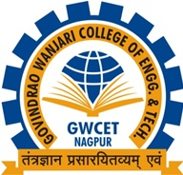

2.4.2 Honours and Recognitions Received by Teachers
2.4.2 Received awards, recognition, fellowships at State, National, International level from Government, recognized bodies during the years
Year of Award | Name of full time teachers receiving awards from state level, national level, international level from Government, recognized bodies. | Designation | Name of the award, fellowship, received from Government or recognized bodies
2019-20 | Mr. Avishkar Wanjari | Assistant Professor | “National Educational Award” for Best Professor in Electrical Engineering Studies
 | Mrs. Ashwini Deshmukh | Assistant Professor | “Bharat Ratna Mother Teresa Gold Medal Award” By Global Economic Progress and Research Organisation New Dehli
 | Dr. Hemant Sonare | Director & Associate Professor | “China Homelife India-2019 Award “ by China -India Textile Co-operative Forum.

PROF. AVISHKAR WANJARI (DEPARTMENT OF ELECTRICAL ENGINEERING)
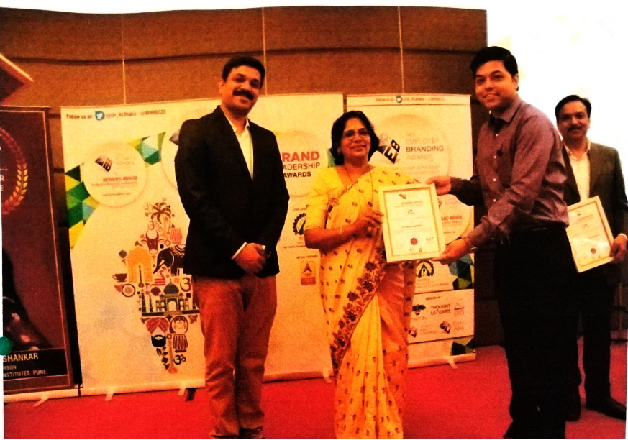
Prof. Avishkar Wanjari Received the National Educational Award “Best Professor in Electrical Engineering Studies” on dated 28 July 2019 (ABP News on dated 28 July 2019) in session 2019-20

CERTIFICATE OF NATIONAL EDUCATIONAL AWARD

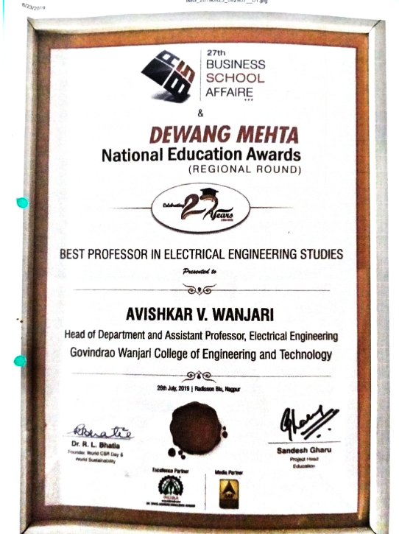
PROF. ASHWINI DESHMUKH (ELECTRONICS AND TELECOMMUNICATION)

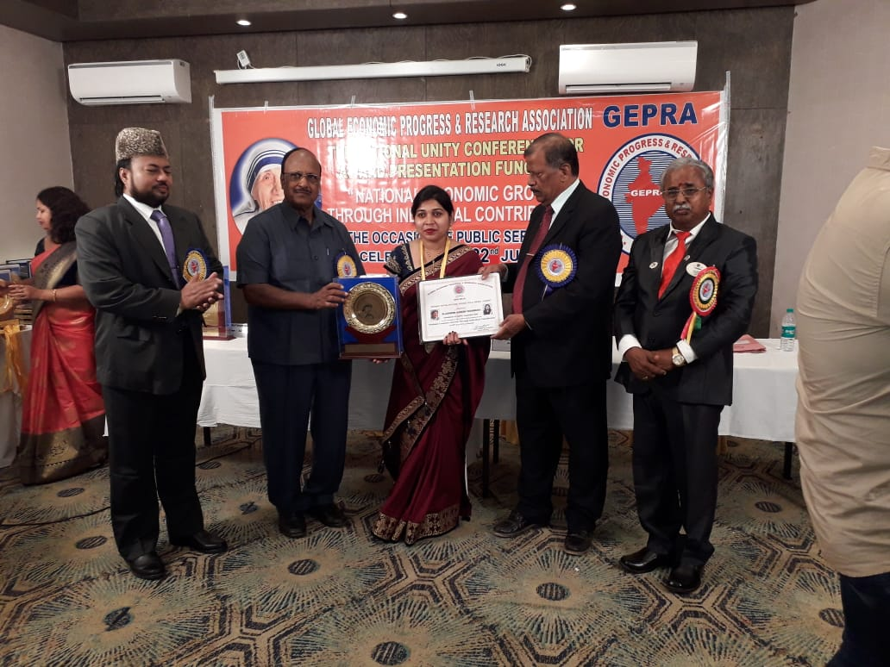

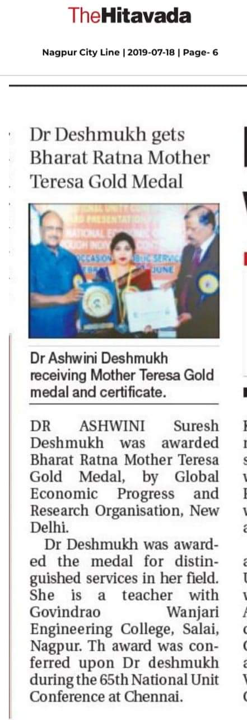
Professor Ashwini Suresh Deshmukh (Assistant Professor, Department of Electronics and Telecommunication) Received “Bharat Ratna Mother Teresa Gold Medal Award” for the Excellence in her Respective Field By Global Economic Progress and Research Organisation New Dehli, on the occasion of 65th National Unity Conference for National Economic Growth Through Individual Contribution on dated 22 June 2019 at Chennai in the Session 2019-20
CERTIFICATE OF BHARAT RATNA MOTHER TERESA GOLD MEDAL AWARD
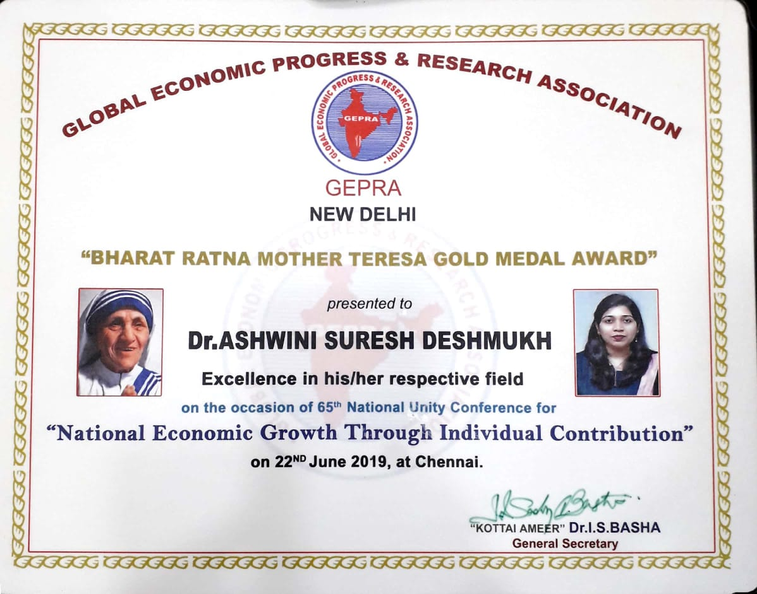
DR. HEMANT SONARE (DEPARTMENT OF MBA)
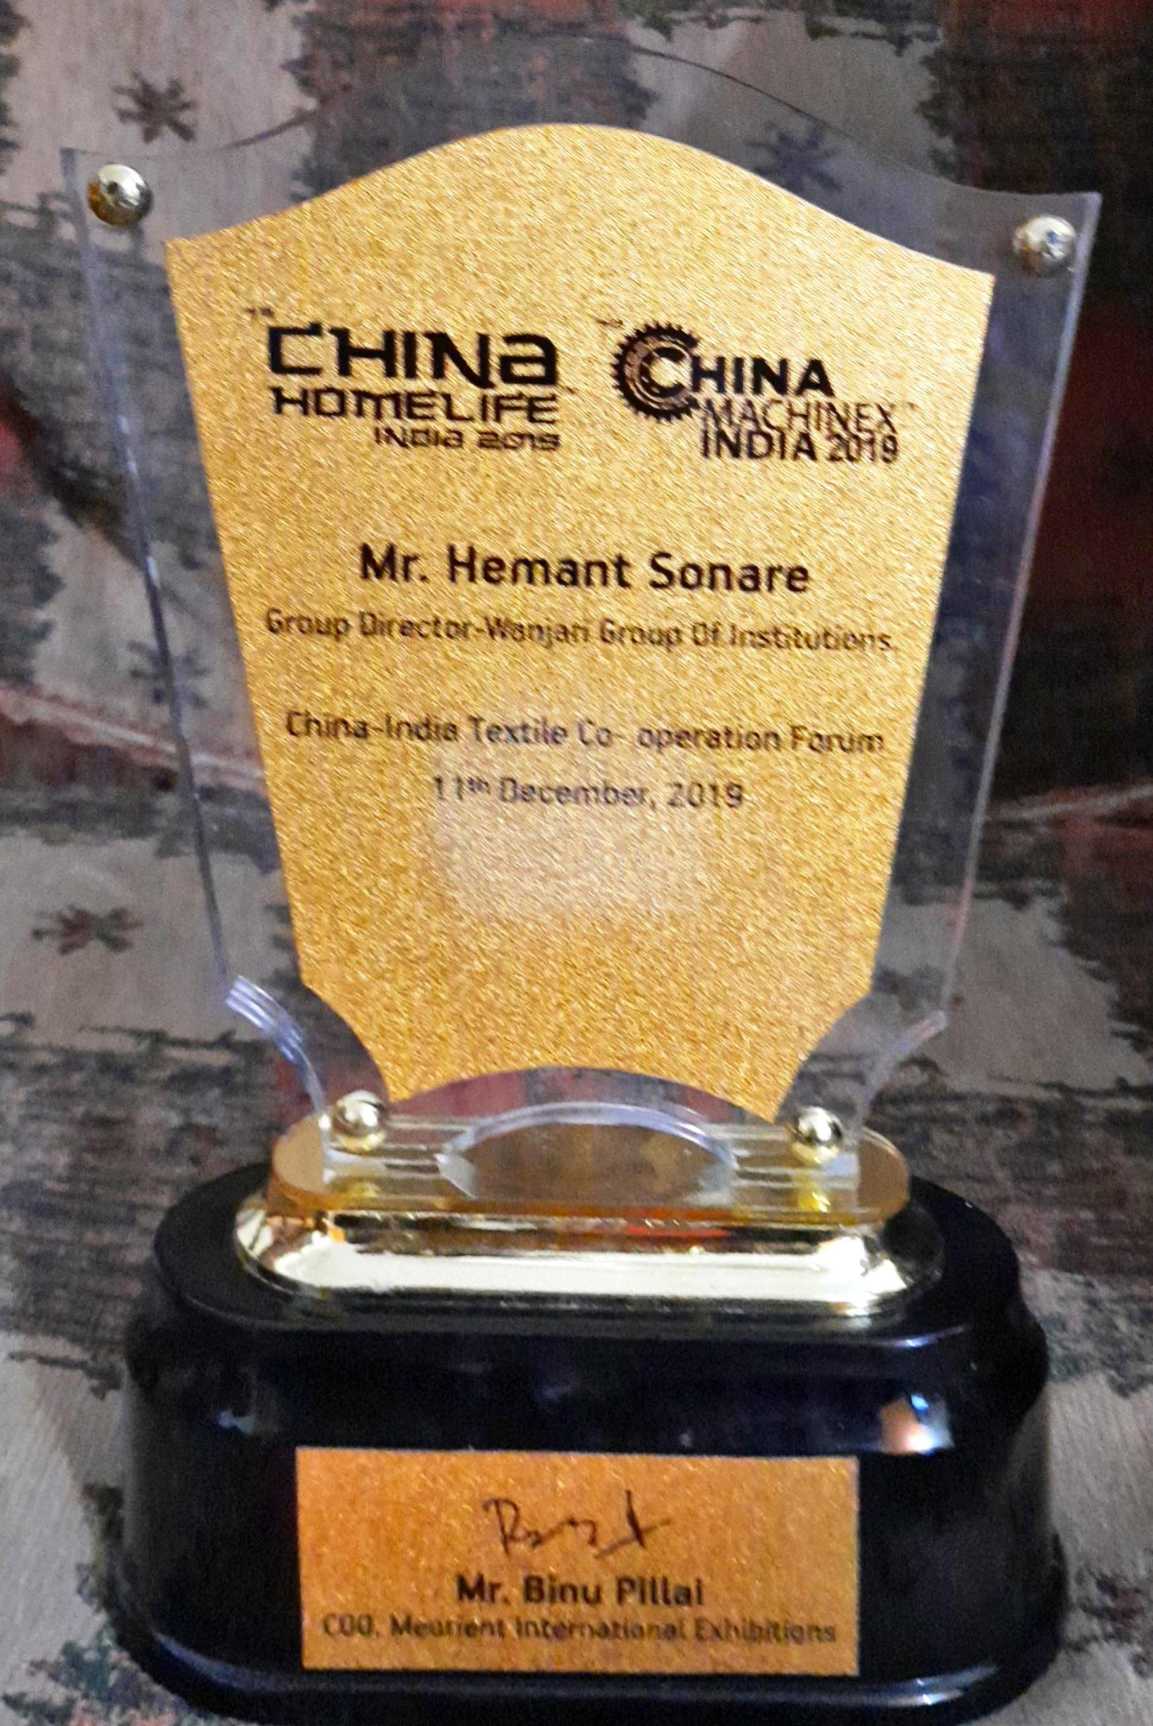
Dr. Hemant Sonare, Director, Wanjari Group of Institution and Associate Professor, Department of MBA Received the China home-Life India Award 2019 by China -India Textile Co-operative Forum on dated 11 December 2019 .

